Xin Yang

NetID: xy213

Type B: Implement a DNN model on an Android smart phone.

Final Project Report

Introduction:

In the final project, I implemented a deep neural network (DNN) on the Android device based on TensorFlow Lite. This neural network helps to perform the finger input user authentication on a PIN pad using vibration signal. The prototype is shown as below.

The input of the neural network is the vibration features extracted using Fast Fourier Transform (FFT) and Mel-frequency Cepstral Coefficient (MFCC). The two features are first normalized respectively, then combined together as a flattened one-dimensional vector.

For the user authentication, I designed 10 classes representing the empty condition (class 0: no user input), and the PIN digits from 1 to 9 corresponding to classes 1 to 9.

Structure:

The structure is a deep neural network with two hidden layers.

The dimension of the input layer is 1\*339. 339 stands for the length of the feature.

The first hidden layer contains 120 neurons, followed by a tanh activation function.

The second hidden layer contains 60 neurons, activated by the sigmoid function.

The output layer generates a probability distribution for 10 classes using the softmax function.

Implementation:

The implementation of the DNN is composed of two parts. The first part is building the model on the desktop PC based on TensorFlow. The training process is completed on the PC, then I save the model as a pb file and transmit into the Android device. The second part is the implemented using Java on the Android platform. The application is developed using Android Studio. The Android client restores the model in the pb file, then feed the real-time extracted feature into the model and performs the prediction.

For a better user experience, I set a 5 seconds duration to train each label. The training process generates 50 training sets for each label. Since the magnitude of data set is relatively small, I use the batch gradient descent method, which treats all the training sets as one batch.

This algorithm achieves over 96% accuracy under real-time systems within 200 epochs.

Below is the confusion matrix of the model. This data is collected from 10 volunteers. Every volunteer is first taught how to use this system, then train the DNN model and press every digit for 10 times. The split ratio of training set and test set is 7:3.

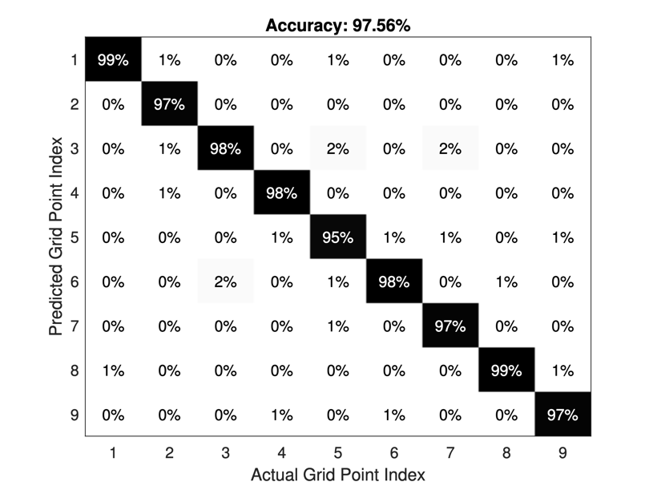

The overall average recognition accuracy achieves 97.56%, and the complete training and prediction is very efficiency. There is no significant delay that can be recognized by the user.